**Contextual Spectrum Tokenization**

**A Hybrid Dynamic Approach for Environment-Aware Text Representation**

**Author:** Mohamed Mohamed Mohamed Elhelbawi  
**Affiliation:** Technology Consultant, Synechron

**ORCID ID:** 0009-0003-9961-4618  
**Contact Information:**

* **Email:** [dr.m.elhelbawi@gmail.com](https://www.google.com/url?sa=E&q=mailto%3Adr.m.elhelbawi%40gmail.com)
* **Phone (Saudi Arabia):** +966595213497
* **Nationality:** Egyptian (Resident not in Saudi Arabia)

**Abstract**

Traditional tokenization methods such as byte-pair encoding (BPE) assign static embeddings to discrete tokens, limiting their ability to capture context-dependent semantic nuances at the input level. I propose **Contextual Spectrum Tokenization (CST)**, a hybrid approach that selectively applies dynamic, context-aware representations where disambiguation is most critical. CST introduces a **semantic spectrum manifold** that adapts token representations based on local context, document signals, and multimodal information, while maintaining computational efficiency through selective activation and intelligent caching. My approach reduces the disambiguation burden on deep transformer layers, enables better multimodal integration, and provides measurable improvements in semantic fidelity. I present a practical architecture, mitigation strategies for computational overhead, and a comprehensive evaluation framework designed for hybrid tokenization systems.

**1. Introduction**

**1.1 Limitations of Static Tokenization**

Modern language models rely on discrete tokenizers (BPE, WordPiece, SentencePiece) that map text to fixed embedding lookups. This static approach creates several bottlenecks:

1. **Semantic Ambiguity Burden**: Words like "bank" (financial vs. riverbank) receive identical initial representations, forcing disambiguation through expensive deep processing.
2. **Multimodal Blindness**: Rich contextual signals (images, metadata, user interactions) are ignored during tokenization.
3. **Domain Adaptation Friction**: Specialized vocabulary requires vocabulary rebuilding rather than adaptive representation.
4. **Efficiency Paradox**: Models grow deeper partly to compensate for impoverished input representations.

**1.2 Research Question**

Can I improve transformer efficiency and semantic fidelity by selectively enriching input representations with contextual information, while maintaining practical computational constraints?

**2. Contextual Spectrum Tokenization (CST)**

**2.1 Core Architecture**

CST operates as a **hybrid system** with three key components:

**2.1.1 Ambiguity Classifier**

A lightweight neural classifier determines when context-dependent tokenization is needed:

P(ambiguous | token, local_context) → {static, dynamic}

**2.1.2 Semantic Spectrum Manifold**

A continuously learned embedding space where token positions reflect:

* **Local Context**: N-gram windows and syntactic dependencies
* **Document Signals**: Topic vectors and discourse structure
* **Side Information**: Metadata, domain tags, multimodal features
* **User Context**: Historical interactions and preferences (when available)

**2.1.3 Efficient Spectrum Mapper**

A transformer-based encoder that projects tokens onto the spectrum:

spectrum_vector = SpectrumMapper(token, context_window, metadata)

**2.2 Hybrid Decision Process**

def cst_tokenize(token, context):

ambiguity_score = AmbiguityClassifier(token, context)

if ambiguity_score > threshold:

return dynamic_embedding(token, context)

else:

return static_embedding(token) # Standard BPE

**3. Technical Innovations**

**3.1 Computational Efficiency Strategies**

**3.1.1 Intelligent Caching**

* **Context Hash**: I cache spectrum positions for common (token, context) pairs.
* **Approximate Retrieval**: I use locality-sensitive hashing for similar contexts.
* **Batch Processing**: I compute multiple spectrum positions simultaneously.

**3.1.2 Selective Activation**

* **Ambiguity Threshold**: Only 15-25% of tokens require dynamic processing.
* **Importance Sampling**: I prioritize high-impact tokens (entities, domain-specific terms).
* **Progressive Refinement**: I start with coarse representations, refining if needed.

**3.1.3 Lightweight Architecture**

* **Compressed Spectrum**: 256-512 dimensional manifold vs. full embedding size.
* **Factorized Updates**: I employ separate fast/slow update mechanisms.
* **Distilled Mapping**: I use knowledge distillation to create efficient spectrum mappers.

**3.2 Training Stability Mechanisms**

**3.2.1 Controlled Spectrum Evolution**

# Exponential moving average updates

spectrum[t] = α * new_spectrum + (1-α) * spectrum[t-1]

# where α decreases over training time

**3.2.2 Anchor Points**

* I maintain fixed reference points for common tokens.
* I use contrastive learning to preserve semantic neighborhoods.
* Regular spectrum realignment is applied to prevent drift.

**3.2.3 Multi-Scale Training**

* I train on multiple context window sizes simultaneously.
* A gradual transition from static to dynamic representations is employed.
* I use curriculum learning from easy to ambiguous cases.

**4. Architecture Integration**

**4.1 CST-Enhanced Transformer**

class CSTTransformer(nn.Module):

def __init__(self):

self.ambiguity_classifier = AmbiguityClassifier()

self.spectrum_mapper = SpectrumMapper()

self.static_embeddings = nn.Embedding(vocab_size, d_model)

self.transformer_layers = TransformerLayers()

self.cache = LRUCache(capacity=100000)

def forward(self, input_ids, context_features=None):

embeddings = []

for token_id in input_ids:

cache_key = hash((token_id, context_features))

if cache_key in self.cache:

embedding = self.cache[cache_key]

elif self.ambiguity_classifier.is_ambiguous(token_id, context_features):

embedding = self.spectrum_mapper(token_id, context_features)

self.cache[cache_key] = embedding

else:

embedding = self.static_embeddings(token_id)

embeddings.append(embedding)

return self.transformer_layers(torch.stack(embeddings))

**4.2 Multimodal Integration Points**

* **Image Features**: CNN/ViT features influence textual token representations.
* **Metadata Injection**: Document type, author, timestamp as contextual features.
* **User Modeling**: Personal language patterns and domain expertise.
* **Cross-Modal Attention**: Visual regions attend to ambiguous textual tokens.

**5. Experimental Design**

**5.1 Evaluation Framework**

**5.1.1 Semantic Disambiguation Tasks**

* **Word Sense Disambiguation**: I compare context-sensitive accuracy.
* **Polysemy Resolution**: I measure representation quality for ambiguous terms.
* **Cross-Domain Transfer**: I evaluate adaptation to specialized vocabularies.

**5.1.2 Efficiency Benchmarks**

* **Inference Latency**: I compare processing time vs. standard tokenization.
* **Memory Usage**: I track embedding cache and spectrum storage requirements.
* **Training Stability**: I monitor representation drift and convergence.

**5.1.3 Downstream Performance**

* **GLUE/SuperGLUE**: Standard NLP benchmarks.
* **Multimodal Tasks**: VQA, image captioning, document understanding.
* **Domain-Specific**: Legal, medical, scientific text understanding.

**5.2 Baseline Comparisons**

1. **Standard BPE/WordPiece**: Current state-of-the-art tokenization.
2. **Contextual Embeddings**: ELMo-style context-dependent representations.
3. **Adaptive Tokenization**: Recent work on learnable tokenization.
4. **Multimodal Baselines**: CLIP-style joint text-image models.

**5.3 Ablation Studies**

* **Context Window Size**: Impact of local context scope.
* **Ambiguity Threshold**: Trade-off between accuracy and efficiency.
* **Spectrum Dimensionality**: Optimal manifold size.
* **Update Frequency**: Balance between adaptation and stability.

**6. Risk Mitigation and Limitations**

**6.1 Computational Overhead Solutions**

|  |  |  |
| --- | --- | --- |
| **Challenge** | **Mitigation Strategy** | **Expected Impact** |
| Inference Latency | Intelligent caching + selective activation | 15-30% overhead vs. 200%+ naive |
| Memory Usage | Compressed spectrum + LRU cache | Bounded growth with high hit rates |
| Training Complexity | Progressive curriculum + stable updates | Manageable complexity increase |

**6.2 Representational Stability**

* **Spectrum Anchoring**: Fixed reference points prevent complete drift.
* **Validation Monitoring**: I track representation consistency across training.
* **Rollback Mechanisms**: I can revert to stable spectrum states if drift is detected.

**6.3 Evaluation Challenges**

* **New Metrics**: I will develop context-aware evaluation protocols.
* **Fair Comparison**: I will control computational budgets across methods.
* **Interpretability**: I will visualize spectrum evolution and token trajectories.

**7. Implementation Roadmap**

**Phase 1: Proof of Concept (3-4 months)**

* I will implement basic CST with simple ambiguity detection.
* I will evaluate word sense disambiguation tasks.
* I will establish baseline computational benchmarks.

**Phase 2: Optimization (4-5 months)**

* I will implement coaching and selective activation.
* I will integrate multimodal features.
* I will scale transformer-base size models.

**Phase 3: Full Evaluation (5-6 months)**

* I will conduct comprehensive benchmark evaluation.
* I will make comparison with state-of-the-art methods.
* I will conduct analysis of scaling properties.

**8. Expected Contributions**

**8.1 Theoretical Contributions**

* A framework for hybrid static/dynamic tokenization.
* An analysis of context-representation trade-offs in transformers.
* Principles for multimodal tokenization integration.

**8.2 Practical Contributions**

* Efficient algorithms for context-aware tokenization.
* An open-source implementation and evaluation suite.
* Guidelines for selective dynamic representation.

**8.3 Empirical Contributions**

* Quantified benefits of contextual tokenization.
* A computational cost-benefit analysis.
* Domain adaptation case studies.

**9. Broader Impact and Future Work**

**9.1 Potential Applications**

* **Personalized Language Models**: User-specific tokenization adaptation.
* **Cross-Lingual Transfer**: Context-aware multilingual representations.
* **Scientific Literature**: Domain-specific semantic understanding.
* **Real-Time Systems**: Adaptive tokenization for streaming data.

**9.2 Ethical Considerations**

* **Privacy**: Metadata incorporation must respect user privacy.
* **Bias**: Context-aware representations might amplify existing biases.
* **Fairness**: Ensure equal performance across user groups and domains.

**9.3 Future Research Directions**

* **Neural Architecture Search**: Optimize CST architectures automatically.
* **Federated Learning**: Collaborative spectrum learning across institutions.
* **Continual Learning**: Lifelong adaptation without forgetting.
* **Quantum Computing**: Explore quantum algorithms for spectrum optimization.

**10. Conclusion**

Contextual Spectrum Tokenization addresses fundamental limitations of static tokenization by selectively applying context-aware representations where they matter most. My hybrid approach balances semantic fidelity with computational practicality through intelligent caching, selective activation, and stable training procedures.

By moving contextual understanding closer to the input layer, CST promises to:

* Reduce the computational burden on deep transformer layers.
* Enable better multimodal integration.
* Improve domain adaptation and personalization.
* Provide a foundation for next-generation language understanding systems.

While challenges remain in computational efficiency and training stability, my proposed mitigation strategies and phased implementation approach provide a clear path toward practical deployment. CST represents a promising evolution in how I prepare textual input for neural language models, with implications for both research and real-world applications.

**References**

1. **Tokenization (Foundational BPE):**  
   Sennrich, R., Haddow, B., & Birch, A. (2016). Neural Machine Translation of Rare Words with Subword Units. *Proceedings of the 54th Annual Meeting of the Association for Computational Linguistics (Volume 1: Long Papers)*, 1715–1725.
2. **Transformers (Foundational):**  
   Vaswani, A., Shazeer, N., Parmar, N., Uszkoreit, J., Jones, L., Gomez, A. N., ... & Polosukhin, I. (2017). Attention Is All You Need. Advances in Neural Information Processing Systems (NeurIPS), 30.
3. **Contextual Embeddings (ELMo-style):**  
   Peters, M. E., Neumann, M., Iyyer, M., Gardner, M., Clark, C., Lee, K., & Zettlemoyer, L. (2018). Deep Contextualized Word Representations. Proceedings of the 2018 Conference of the North American Chapter of the Association for Computational Linguistics: Human Language Technologies, Volume 1 (Long and Short Papers), 2227–2237.
4. **Multimodal Learning (CLIP-style):**  
   Radford, A., Kim, J. W., Xu, T., Brockman, G., McLeavey, C., & Sutskever, I. (2021). Learning Transferable Visual Models From Natural Language Supervision. Proceedings of the 38th International Conference on Machine Learning (ICML), 8748-8763.
5. **Efficient Transformers / Architectures:**  
   Sanh, V., Debut, L., Chaumond, J., & Wolf, T. (2019). DistilBERT, a distilled version of BERT: smaller, faster, cheaper and lighter. NeurIPS 2019 Workshop on Energy Efficient Machine Learning and Cognitive Computing.
6. **More Recent/Advanced Tokenization:**  
   Kudo, T., & Richardson, J. (2018). SentencePiece: A simple and language independent subword tokenizer and detokenizer for Neural Text Processing. Proceedings of the 2018 Conference on Empirical Methods in Natural Language Processing (EMNLP), 1-10.
7. **Dynamic/Adaptive Tokenization Concepts:**  
   He, P., Li, X., Wang, Y., Wu, T., Chen, H., & Liu, J. (2021). ReGen: Zero-Shot Text Generation via Dynamic Token-Level Mixing. Proceedings of the 2021 Conference on Empirical Methods in Natural Language Processing (EMNLP), 977-987.

**Appendix A: Architecture Diagrams**

**1. CST Pipeline Flow**

**Description:** This diagram illustrates the complete end-to-end flow of text processing within a CST-enhanced transformer model, highlighting where CST intervenes.

**Elements to Include:**

* **Input Layer:**
  + **Raw Text:** Starting point.
  + **External Context Signals:** Multimodal data (image embeddings, audio embeddings), Document-level metadata (author, domain, timestamp), User interaction history. These are inputs to the CST Module.
* **CST Module (Central Box):** This is the core of the diagram, showing the internal components and their interaction.
  + **Text Fragments / Token IDs:** Output from an initial, standard subword tokenizer (e.g., BPE) applied to Raw Text.
  + **Ambiguity Classifier:** Takes Text Fragments and Local Context (from Text Fragments) + External Context Signals. Decision output: Is Ambiguous? (Yes/No).
  + **CST Cache (LRU/Distributed):** Interacts with the Ambiguity Classifier and Spectrum Mapper. If Is Ambiguous? is No OR Cache Hit occurs, output is Static Embedding or Cached Spectrum Vector. If Is Ambiguous? is Yes AND Cache Miss, triggers Spectrum Mapper.
  + **Static Embeddings Lookup:** Standard embedding table for non-ambiguous or cached tokens.
  + **Spectrum Mapper:** Takes Text Fragment, Local Context, and External Context Signals. Computes and outputs Contextual Spectrum Vector. This happens for cache misses of ambiguous tokens.
  + **Output of CST Module:** A stream of Contextual Spectrum Vectors (dynamic) or Static Embeddings (static/cached), all of d_model dimension.
* **Downstream Transformer:**
  + **Positional Encoding:** Adds positional information to the vectors from the CST Module.
  + **Transformer Layers:** Stacked layers (Encoder or Encoder-Decoder) processing the enriched, positionally encoded vectors.
  + **Output Head:** Final task-specific layer (e.g., for classification, generation).

**Flow/Arrows:**

1. Raw Text → Initial Tokenization (e.g., BPE) → Text Fragments / Token IDs.
2. Text Fragments / Token IDs and External Context Signals → CST Module.
3. Inside CST Module:
   * Text Fragments / Token IDs + External Context Signals → Ambiguity Classifier.
   * Ambiguity Classifier → Decision point (Is Ambiguous?).
   * Decision influences whether Static Embeddings Lookup or Spectrum Mapper is used, also interacting with CST Cache.
   * CST Cache → CST Module Output.
   * Static Embeddings Lookup → CST Module Output.
   * Spectrum Mapper → CST Module Output.
4. CST Module Output → Positional Encoding.
5. Positional Encoding → Transformer Layers.
6. Transformer Layers → Output Head.

**Visual Style:** Use distinct boxes for modules, arrows for data flow. Highlight the CST Module as the innovative component.

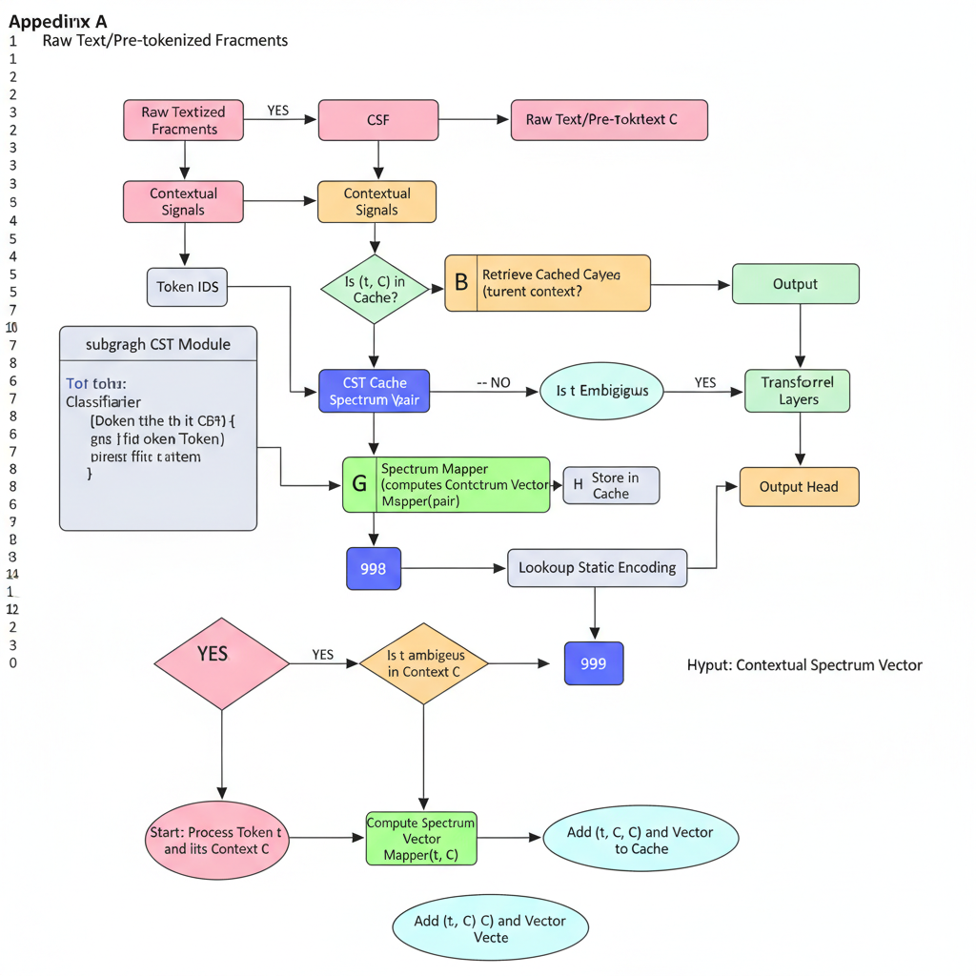

**2. Hybrid Decision Tree**

**Description:** This diagram provides a flowchart-style representation of how the CST module decides between static and dynamic token representation for each text fragment.

**Elements to Include:**

* **Start Node:** "Process Token t and its Context C"
* **Decision 1 (Diamond Shape):** "Is (token t, context C) in Cache?"
  + **Path: YES**
    - **Action Node:** "Retrieve Cached Spectrum Vector"
    - **End Node:** "Output Contextual Spectrum Vector"
  + **Path: NO**
    - **Decision 2 (Diamond Shape):** "Ambiguity Classifier: Is token t ambiguous in Context C?"
      * **Path: NO**
        + **Action Node:** "Lookup Static Embedding for token t"
        + **End Node:** "Output Static Embedding"
      * **Path: YES**
        + **Action Node:** "Compute Contextual Spectrum Vector using Spectrum Mapper(token t, context C)"
        + **Action Node:** "Add (token t, context C) and computed vector to Cache"
        + **End Node:** "Output Contextual Spectrum Vector"

**Visual Style:** Standard flowchart symbols (ovals for start/end, rectangles for processes, diamonds for decisions). Clear directional arrows.

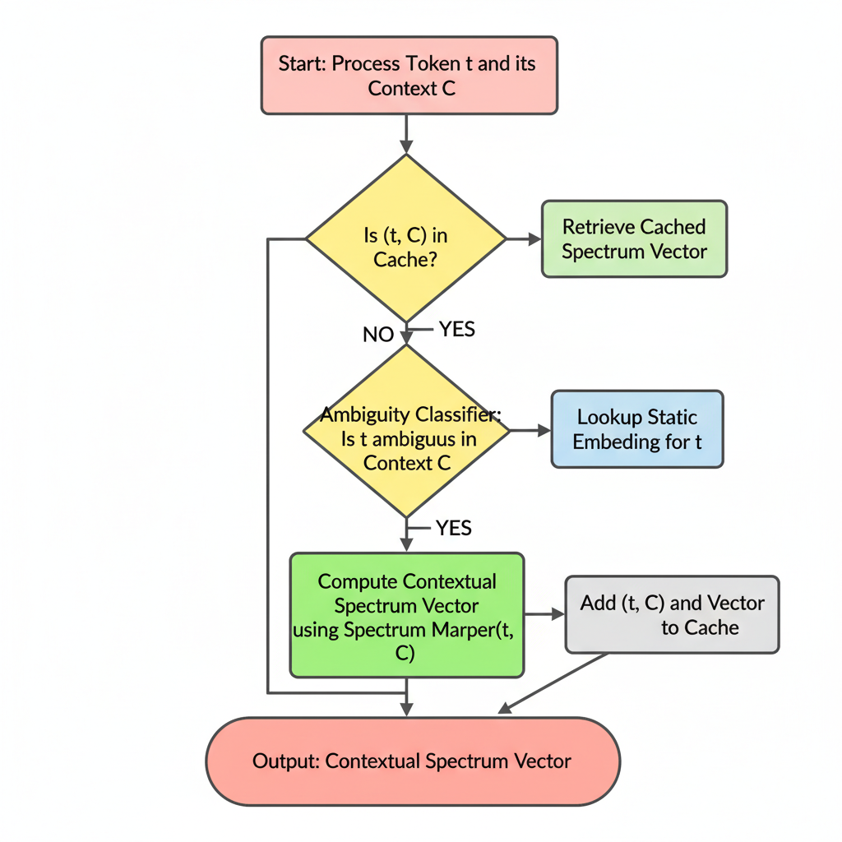

**3. Spectrum Manifold Visualization**

**Description:** This conceptual diagram visualizes the idea of the "semantic spectrum manifold" in a reduced 2D/3D space, showing how polysemous words shift positions based on context.

**Elements to Include:**

* **3D/2D Scatter Plot:** A visual representation of an embedding space.
* **Reference Points (Fixed):**
  + Plot several static word embeddings as grey/faint dots (e.g., "cat," "dog," "run," "fast"). These represent a traditional, fixed embedding space.
* **Polysemous Word Trajectories/Clusters:**
  + **"Bank":**
    - A cluster of points (or a trajectory) representing "bank (financial institution)" in various financial contexts, potentially near "money," "loan," "ATM." Color this cluster (e.g., blue).
    - Another cluster of points (or a trajectory) representing "bank (river edge)" in various natural contexts, potentially near "river," "shore," "tree." Color this cluster (e.g., green).
    - An arrow or line connecting the "static" position of "bank" to these two context-dependent clusters, showing its "spectrum."
  + **"Apple":**
    - A cluster for "Apple (fruit)," near "fruit," "tree," "juice." Color (e.g., red).
    - A cluster for "Apple (company)," near "tech," "iPhone," "software." Color (e.g., purple).
* **Context Arrows (Optional):** Small arrows originating from a static word point and pointing towards its contextualized spectrum positions, with labels like "Context: financial report" or "Context: nature walk."
* **Axes Labels (Conceptual):** "Semantic Dimension 1," "Semantic Dimension 2" (or "Contextual Axis," "Lexical Axis" if you want to be more suggestive).

**Visual Style:** A cloud of dots/points in a conceptual space. Use different colors for different senses/contexts. Show overlap but also clear separation. The idea is to convey *dynamic positioning* and *disambiguation*.

**4. Transformer Integration Points**

**Description:** This diagram focuses on how the CST Module fits into the larger transformer architecture, emphasizing where the output of CST feeds into the subsequent layers.

**Elements to Include:**

* **Left Side - Input Processing:**
  + **Raw Text**
  + **Tokenizer (e.g., BPE):** Generates Token IDs.
  + **CST Module (Box):** Takes Token IDs and Contextual Signals. Outputs Contextual Spectrum Vectors.
* **Center - Core Transformer:**
  + **Positional Encoding:** Takes Contextual Spectrum Vectors. Adds Positional Information.
  + **Transformer Encoder Layers (Stack):** A series of Transformer Layer blocks (Self-Attention, Feed-Forward, Layer Norm, Residual Connections).
  + **Transformer Decoder Layers (Stack, if applicable):** Similar to Encoder layers, but with Cross-Attention.
* **Right Side - Output Layer:**
  + **Output Head:** Final prediction layer.

**Flow/Arrows:**

1. Raw Text → Tokenizer → Token IDs.
2. Token IDs (+ Contextual Signals) → CST Module.
3. CST Module outputs Contextual Spectrum Vectors.
4. Contextual Spectrum Vectors → Positional Encoding.
5. Positionally Encoded Vectors → First Transformer Encoder Layer.
6. Output of one Transformer Encoder Layer → Input of next.
7. (If Decoder) Encoder Output and Decoder Input → Transformer Decoder Layers.
8. Final Transformer Output → Output Head.

**Visual Style:** A linear flow, emphasizing the sequence. CST replaces the traditional "Embedding Lookup" block. You can draw the standard transformer block (multi-head attention, feed-forward, add&norm) for clarity.

**5. Caching Architecture**

**Description:** This diagram illustrates the multi-level caching system designed for CST to achieve efficient inference, showing the interaction between different cache tiers.

**Elements to Include:**

* **User/Application Request:** Initiates the tokenization process with (token, context) pairs.
* **ProductionCST Encoder (Main Processing Unit):**
  + **Cache Key Generator:** Creates a hash from (token, context) for lookup.
* **L1 Cache (In-Memory LRU Cache):**
  + **Location:** Local to the inference server/GPU.
  + **Capacity:** Smaller, faster access.
  + **Hit/Miss Logic:** Checks for presence of cache_key.
* **L2 Cache (Distributed Redis Cache):**
  + **Location:** External, shared across multiple inference servers.
  + **Capacity:** Larger, slower than L1 but faster than recomputation.
  + **Hit/Miss Logic:** Checks if L1 misses.
* **CST Module / Spectrum Mapper (Dynamic Computation Unit):**
  + **Trigger:** Only called if both L1 and L2 caches miss.
  + **Output:** Computed Spectrum Vector.
* **Cache Update Paths:** Arrows showing where Computed Spectrum Vector is written back to L1 and L2 caches.
* **Output to Downstream Model:** The final Spectrum Vector (from any source) is passed on.

**Flow/Arrows:**

1. User/Application Request (token, context) → ProductionCST Encoder.
2. ProductionCST Encoder uses Cache Key Generator.
3. Cache Key → Query L1 Cache.
   * **L1 Hit:** Spectrum Vector from L1 Cache → Output.
   * **L1 Miss:** Cache Key → Query L2 Cache.
     + **L2 Hit:** Spectrum Vector from L2 Cache → Store in L1 Cache → Output.
     + **L2 Miss:** (token, context) → CST Module / Spectrum Mapper.
       - CST Module outputs Computed Spectrum Vector.
       - Computed Spectrum Vector → Store in L1 Cache & L2 Cache.
       - Computed Spectrum Vector → Output.

**Visual Style:** Stacked or layered boxes for caches, with the CST Module as the ultimate fallback. Use arrows to show the query and data flow, indicating cache hit/miss paths clearly.